Assignment 22 (March 20 - 25)

1. Solve the following linear program:

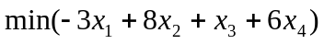
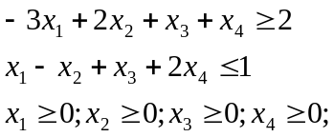

2. Solve the following difference equations and analyze the time paths:
a) 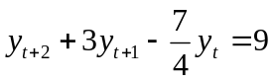 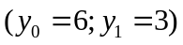
b) 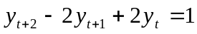 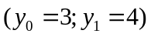
c) 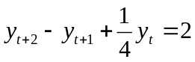 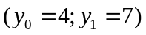

3. Solve the following difference equation and analyze the time path:
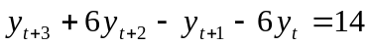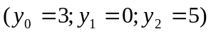

4. Given the pay-off bi-matrix

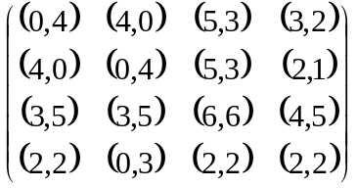

find Nash equilibrium (equilibria) in pure strategies.
5. Given the pay-off bi-matrix
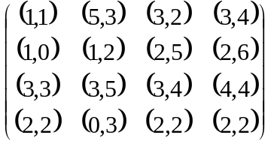

Find all Nash equilibria in pure and mixed strategies.

